**UI Testing for Odisha Police Website**

**1. Test Information**

* **Test Case ID**: UI-001
* **Test Case Name**: UI Testing for Odisha Police Website
* **Test Date**: 17 Oct
* **Tested By**:
* **Website URL**: <https://mtpl.work/odisha-police/>

**2. Preconditions**

* User must have internet access.
* User should be using a supported browser (e.g., Chrome, Firefox, Edge).

**3. Test Environment**

* **Browser**: e.g., Chrome
* **Browser Version**: 129.0.6668.101
* **Operating System**: e.g., Windows 10

**4. Test Images and Findings**

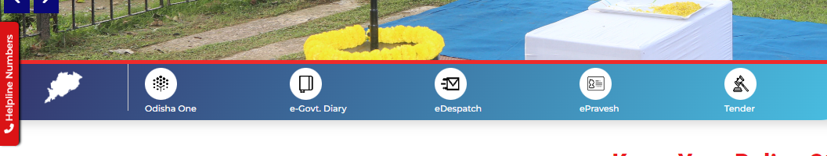

Figure 1link not given

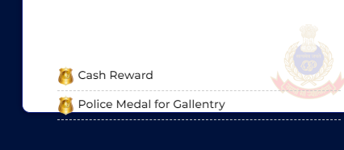

Figure 2outside text ( text should inside while scrolling)

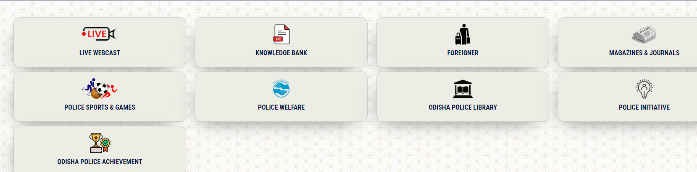

Figure 3link not given

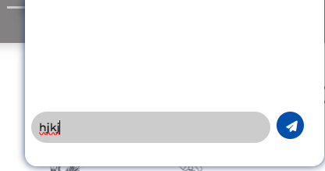

Figure 4chatbot not working

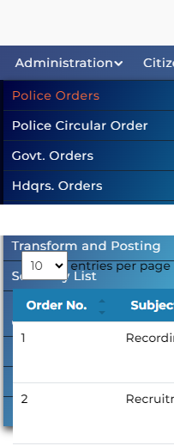

Figure 5Hover(after white border) in under menu vanish after hover this happen in all the menus expect about us main menu

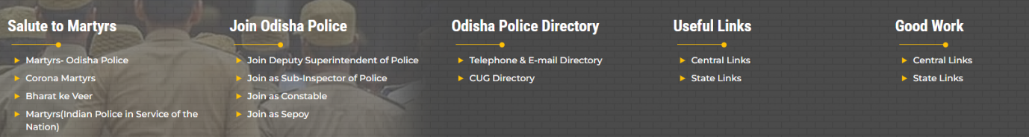

Figure 6 Lnk not given

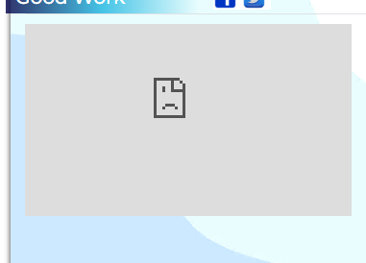

Figure 7image not showing

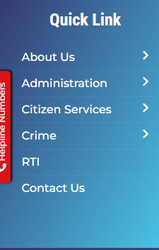

Figure 8 all links in side of of all page expect home page, link is not given

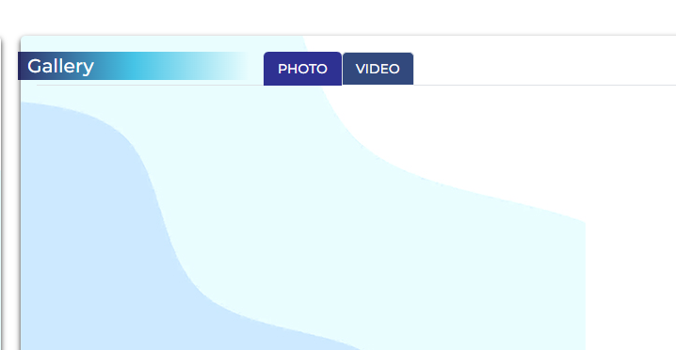

Figure 9video not added

**Eorrer or not designed pages**

<https://mtpl.work/odisha-police/en/sun/page/odisha-police-museum>

<https://mtpl.work/odisha-police/en/sun/hdqrs-orders>

<https://mtpl.work/odisha-police/en/sun/subpage/29/arakhi>

Pdf in Tender & Quotations

<https://mtpl.work/odisha-police/tenderPdfPath/1721992892_download.pdf>

<https://mtpl.work/odisha-police/tenderPdfPath/1722233241_download.pdf>

Press Note

Error while click text inside box (<https://mtpl.work/odisha-police/storage/pressnote/>)

Administration. > all submenu have pdf eighter demo or 404 error.

Citizen service>

* 1. Citizen portal page shown invalid reqest
  2. Safety tips: accordian are not we structured. It causes UX, it should be, if one title open anathor should be close.
  3. <https://mtpl.work/odisha-police/en/sun/page/police-grievance> (content not available
  4. Rti : [Cercular/Govt. Orders on RTI](https://mtpl.work/odisha-police/storage/rti) – 404 error